COMPANY PROFILE

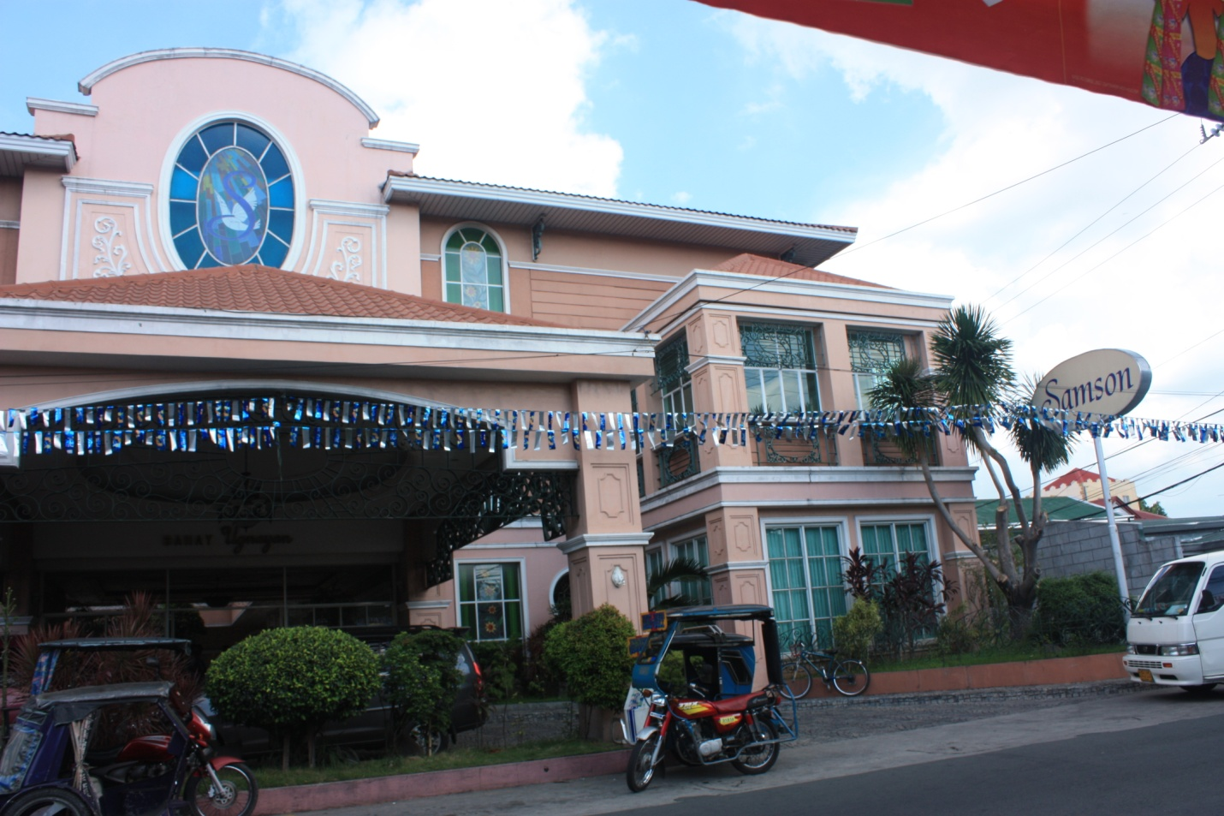

COMPANY NAME FUNERARIA SAMSON, INC.

LOCATION 145 Bayan Luma I Imus, Cavite Philippines, 4103

CONTACT NOS. (046) 471-2675/471-3375
Fax (046) 471-1098

EMAIL bahay_ugnayan@hotmail.com

BRANCH LOCATIONS Buhay-na-Tubig, Imus, Cavite
Maliksi, Bacoor, Cavite
Molino, Bacoor, Cavite
Poblacion, Kawit, Cavite
Bagbag, Rosario, Cavite
Tejero, Gen. Trias, Cavite

NO. OF EMPLOYEES 53

COMPANY HISTORY

1928 | In 1928, RITA MONZON-SAMSON established FUNERARIA SAMSON in Imus, Cavite. Extending care and interment services to bereaved families of fellow Caviteños, business carried on through World War II. It closed in 1965 when Rita Monzon-Samson departed her beloved family.
1976 | CECILIA SAMSON DEL MUNDO, one of the grandchildren, persevered to resume the institution founded by her grandmother. FUNERARIA SAMSON in Imus, Cavite reopened in 1976.
1983 | Reaching out to more kababayans, two branches were developed. FUNERARIA SAMSON opened its 1st & 2nd branch in Malamok, Kawit and Bagbag, Rosario, compounded to help more families on bereavement arrangements.
1984 | With rising residency in the neighboring towns, the 3rd branch was opened in Maliksi, Bacoor.
1994 | Along with the growing economy, FUNERARIA SAMSON widened its reach as it opened another branch, the 4th in Tejero, Gen. Trias.
1997 | FUNERARIA SAMSON further expanded and opened its 5th branch in the heart of Cavite City.
2000 | Moving forth to provide the community more competent services, BAHAY UGNAYAN – SAMSON VIGIL SPACES was completed in 2000. Interment settlements will be effortless with accessible and readily available to individual chapels of various classifications and design. The modern, refined rooms each have a kitchen area, lounge and restroom. Furnished in a lighthearted ambience visiting friends and relatives can remember loved ones in gracious peaceful vigil spaces.
2004 | FUNERARIA SAMSON opened its 6th branch in Molino, Bacoor.
2006 | In 2006, FUNERARIA SAMSON relocated its Kawit branch from Malamok to Poblacion, Kawit because the former site will be expropriated.
2007 | After 3 years, FUNERARIA SAMSON opened its 7th branch in Buhay-na-Tubig, Imus while the Cavite branch has to close due to end of lease contract.
Present | Sincerely at the service of the people of Cavite, the FUNERARIA SAMSON has integrated to host all preparations for a most tranquil and soulful last rites on the dearly departed. Assuredly, the company will continue its support and devotion to the populace of the entire province of Cavite.

AFFILIATES Rita Samson Memorial Garden Inc.
C. Ancheta Crafts

BOARD OF DIRECTORS

ROMEO A. ANCHETA
Chairman of the Board

CECILIA M. ANCHETA

FLORINA S. GIRON

RODERICO D. ANCHETA

ROCHELLE D. ANCHETA

MARICEL R. RODRIGUEZ

CORPORATE OFFICERS

ROMEO A. ANCHETA
President

CECILIA M. ANCHETA
Vice President/Treasurer

RODERICO D. ANCHETA
Chief Operations Officer

MARICEL R. RODRIGUEZ
Corporate Secretary

NOEL H. DE GUZMAN
Operations Manager

LUZVIMINDA S. PALOMARES
General Manager

LOCATION MAP

BRANCHES

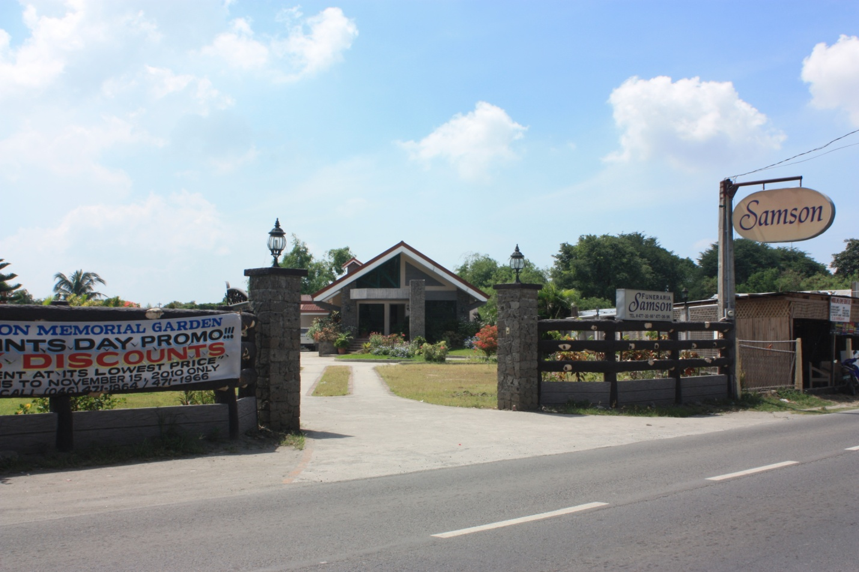

BUHAY-NA-TUBIG
Imus, Cavite

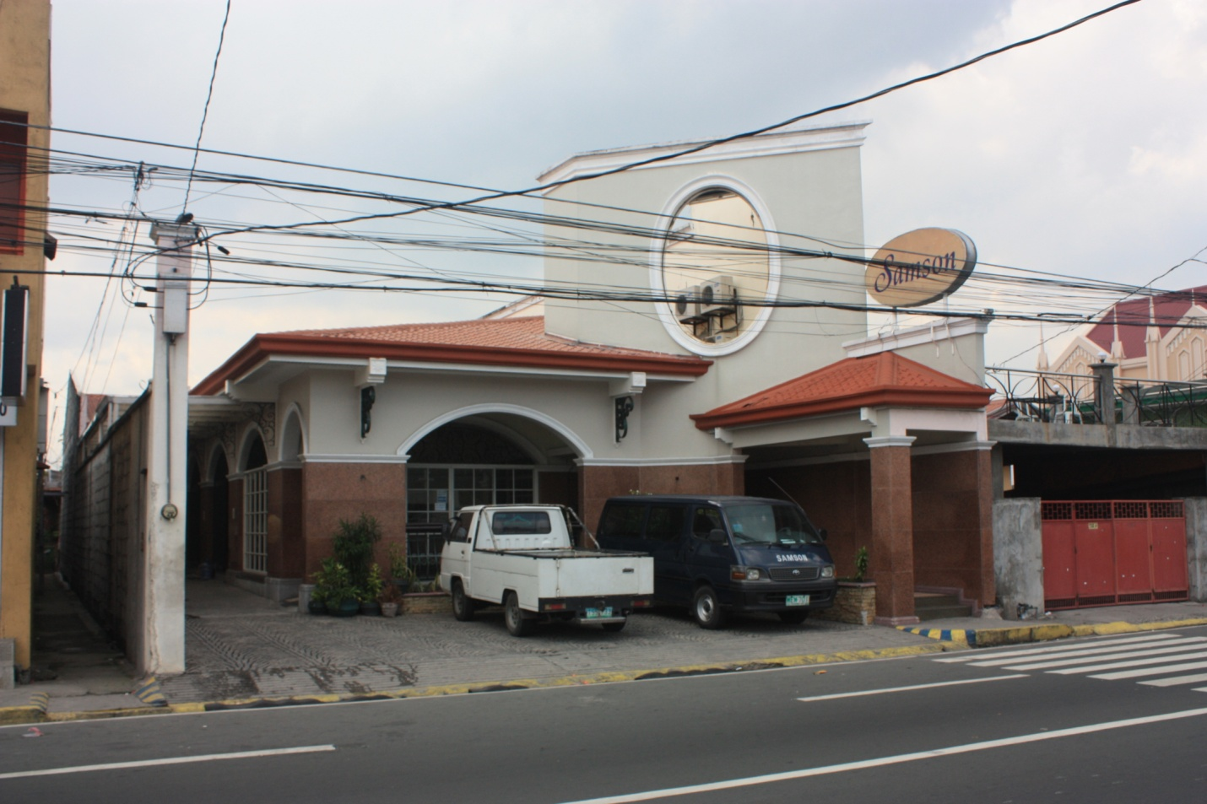

BACOOR
Maliksi, Bacoor, Cavite

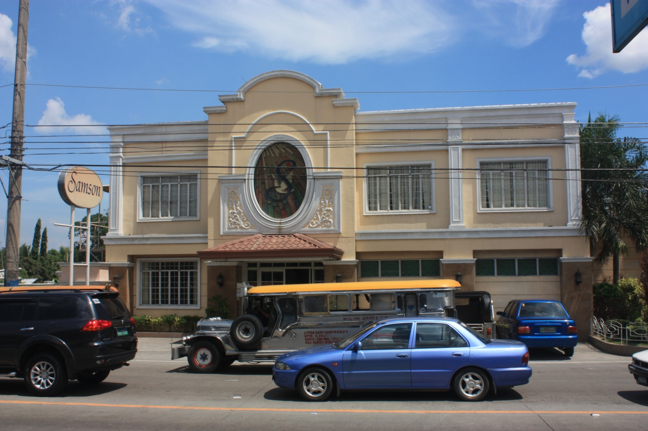

MOLINO
Bacoor, Cavite

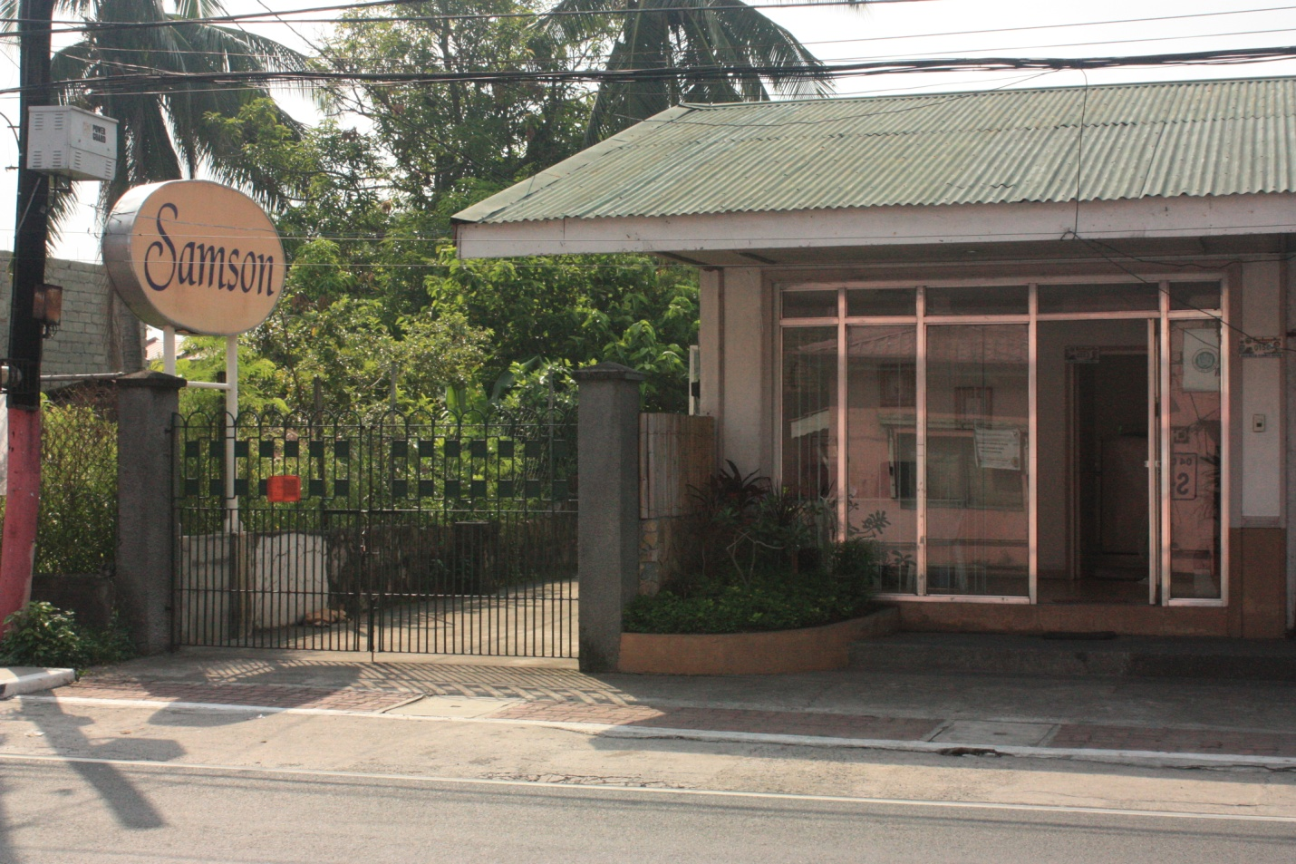

KAWIT
Poblacion, Kawit, Cavite

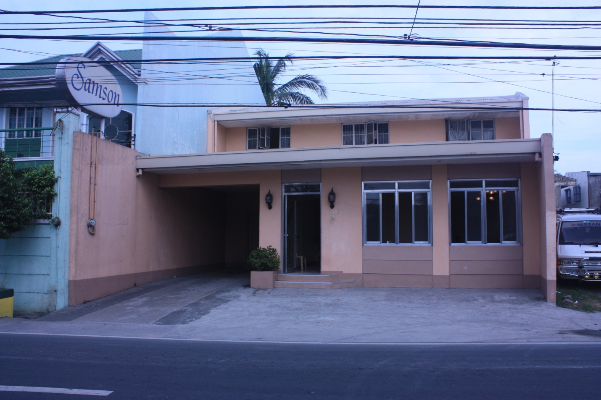

ROSARIO
Bagbag, Rosario, Cavite

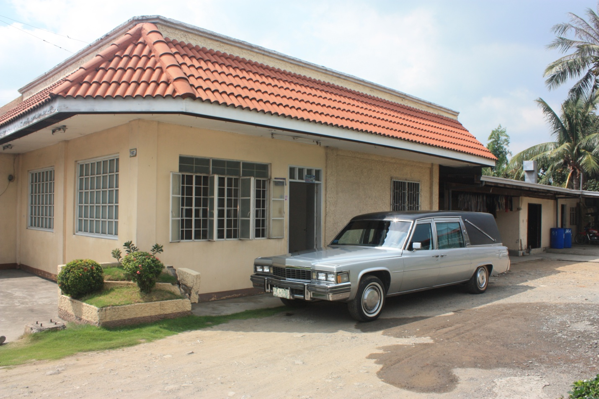

TEJERO
Tejero, Gen. Trias, Cavite

